

CIS C290

M02 Lab Assignment: Setup Python Environment

You are only required to complete Option 1 or Option 2 activity. However, you are welcome to complete both options.

Part 1. Setup a Python Environment

- Option 1. Watch the Google Colab tutorials from the learning materials and setup a Google Colab account. Include a screenshot of the environment.

- Option 2. Watch the Anaconda tutorials from the learning materials and set up Anaconda with either Jupyter Notebook, NumPy, or Spyder.

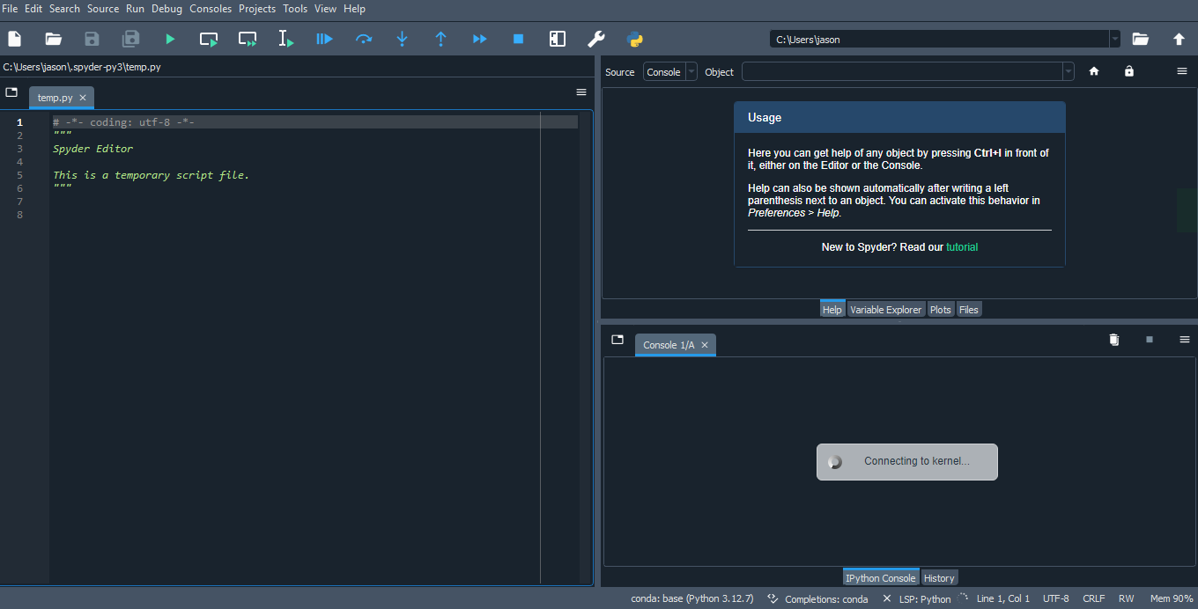

Part 2. In a minimum of 3 sentences, describe your experience with the assignment. Indicate which resources you used.

Since I have taken an OpenCV course online, I have already installed Anaconda in my PC. Therefore, I only needed to setup my Jupyter Notebook, NumPy, and Spyder environments. I decided to install Spyder as it is similar to R-studio’s GUI and I have worked with R-studio before. During this process, however, I had some issues with the installment not having proper dependencies installed, so I had to reinstall Spyder and install PyQt5 with the help of Microsoft Copilot.

